Step 1: Open RPA and use the following format to search for the Patients Eligibility.
For IL :
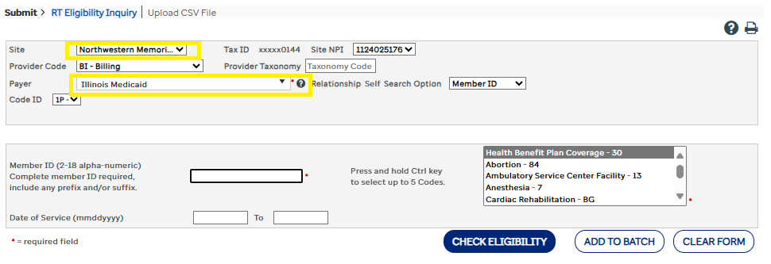
For MO:
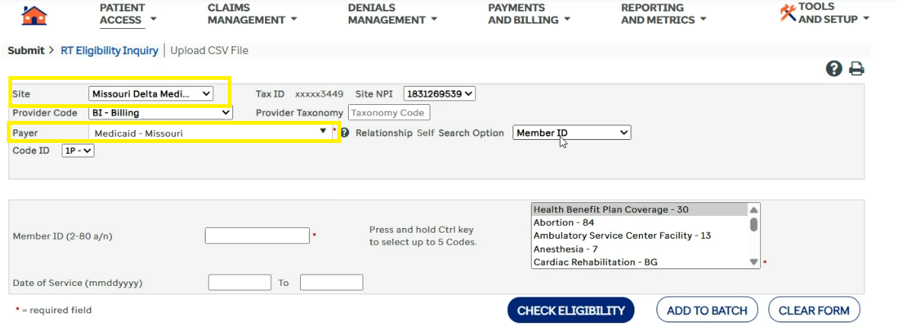
For WA:
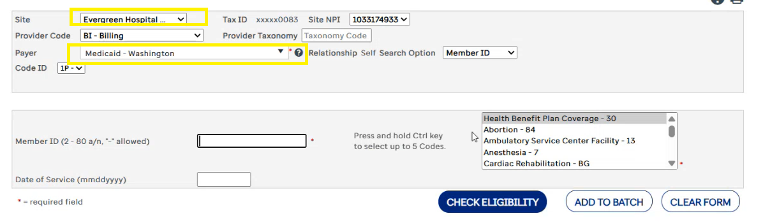

Step 2: We can use different option to check eligibility on RPA depends on the available data on excel file(live tracker).
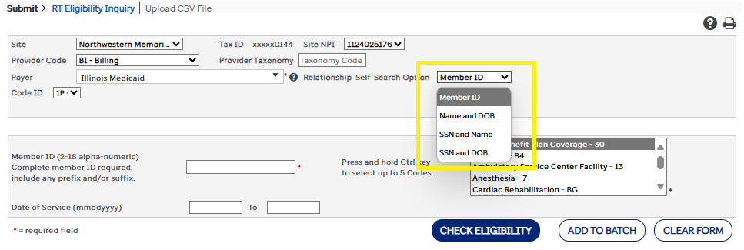
Step 3: Proceed to Step 4 if the eligibility is Active. If eligibility doesn’t show active (REJECTED , INACTIVE , etc.) then note the Live tracker regarding the status of eligibility. Then proceed to the next Patient.
Example:
Status : No Eligibility
OGA Notes: Rejected
Step 4: If the eligibility is Active, then Go to PACE click visit then change the status of visit from hold to Manager Review. Then the Was pt screened put Yes , Screen date change to today or yesterday's date and then hit save.
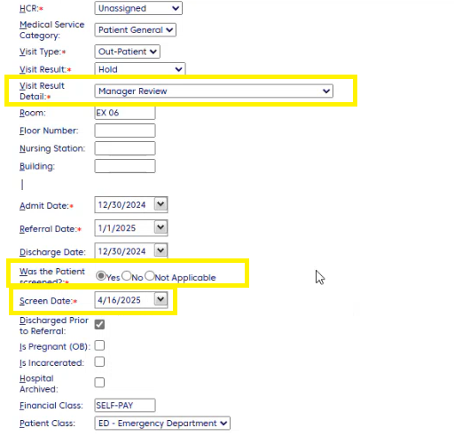

Step 5: Add note on PACE with the following format:
HCR , Custom Note and Private.
Format: RPA shows active Medicaid RIN # (place RIN number)
Example:
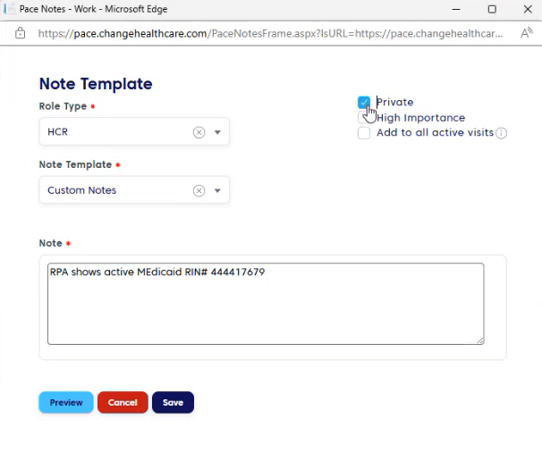

Step 6: Go back to RPA. Print the page(right click select print). Save the PDF as (Name of the Patient POS)
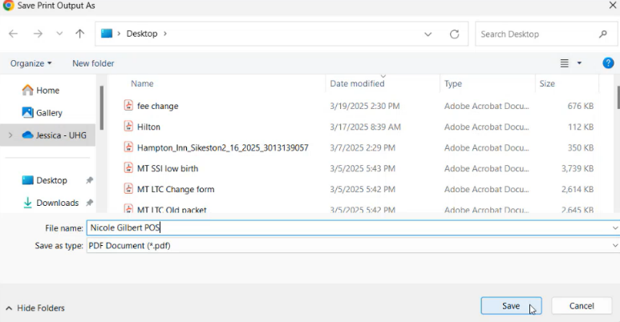
Example: Nicole Gilbert POS

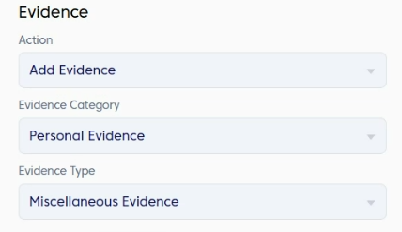
Step 7: Once PDF is downloaded, go back to PACE and click Evidence. Please follow this format in uploading the evidence:

Hit save and proceed to the next patient.

Reminders:
- If the account is on billing list, just add evidence (Pdf from RPA)
- For IL patients, if the eligibility is temporary, we need to treat that as not active (step 3)

